Chapter 16, Solution 13.

Using Fig. 16.36, design a problem to help other students to better understand circuit analysis using Laplace transforms.

Although there are many ways to solve this problem, this is an example based on the same kind of problem asked in the third edition.

Problem

Find v_{x} in the circuit shown in Fig. 16.36 given v_{s} = 4u(t) V.

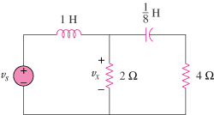

Figure 16.36
For Prob. 16.13.

Solution

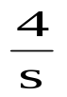
4
+
V_{x}
−
s

+
−
2
8/s

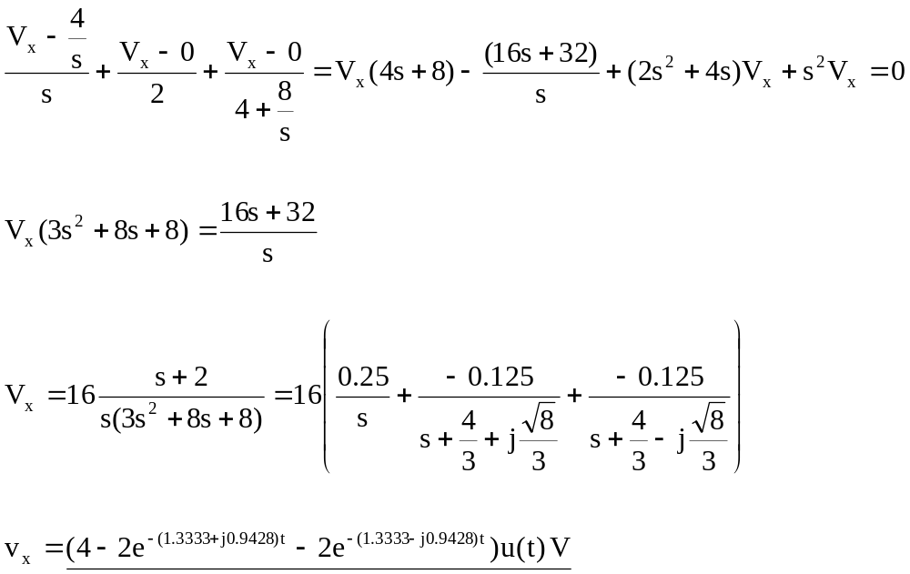

v_{x} = 